**Video Guide: Physical Properties of Soil**

***Soil Texture***

1. Describe the properties of sand, silt, and clay.

**Sand is the largest particle type with a parent material of quartz or other silica-heavy minerals. The particles do not stick to each other and due to the large, large pores form leading to higher water infiltration and aeration. High proportions of sand in soil lead to poor water and nutrient retention.**

**Silt is a medium-sized particle, but is closer in diameter to clay than sand. It has a powdery texture, holds a lot of water, and erodes easily.**

**Clay is the smallest soil particle. Because of this, there are little to no gaps between them, so high amounts of clay reduce water infiltration. Clay can chemically bond to nutrients so it also retains nutrients well.**

1. Based on the soil triangle, identify the type of soil that would have 20% sand, 70% silt, and 10% clay.

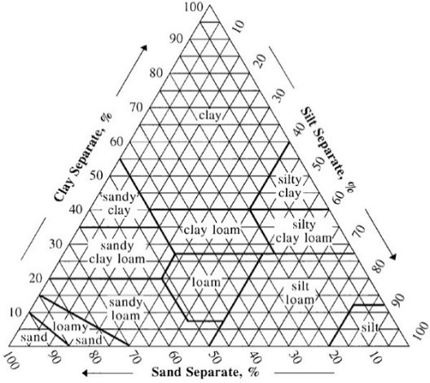

**Silt loam**

1. Describe the characteristics of coarse soils compared to fine soils.

Coarse soils are good at letting water infiltrate and percolate through the soil. Fine soils are good at holding onto plant nutrients and water. Coarse soils are mechanically easier to work. Fine clay-heavy soils hold onto more organic matter and store more carbon.

***Physical Properties of Soil***

1. Define particle density and bulk density.

**Particle density is the density of the solid soil particles only, while bulk density is the mass of undisturbed oven dried soil.**

1. Describe how bulk density affects pore space.

**Higher bulk density correlates with less pore space, because solid soil particles have more mass than air.**

1. Describe the benefits of soil structure.

**Soil structure improves soil permeability, soil aeration, water infiltration, and organic matter retention. It also protects the soil from water and wind erosion, as well as promoting root growth and holding nutrients near the roots.**

1. Describe how soil structure can be degraded.

**Sand doesn’t stick to itself so sandy soils typically lack structure to begin with. Soil with high clay content may become structureless by being tilled or by being compacted until it sticks as a solid mass.**

1. Describe how soil structure can be improved.

**One way soil structure can be formed is chemically, by reactions between minerals in the soil. Another way soil structure can be formed is by things moving through the soil and pushing it around, like earthworms digging or roots growing. The mycelium of a fungal colony can form soil structure, as can bacterial activity.**

1. Describe ways to improve soil tilth.

**Reducing the frequency a field is tilled can improve soil tilth by preventing aggregate destruction. Cover cropping and adding organic matter can improve tilth, as can reducing the overall amount of traffic and weight that goes over the soil. Condensing traffic into the same row can minimize the amount of land that gets impacted.**

1. Describe what effect temperature has on soil health.

**Temperature affects seed germination time and viability, as well as the availability of water and nutrients. Root growth is increased in warmer temperatures, as is biological activity overall. Some ecosystems are fire-dependent and require fire to clear vegetation and provide more light to the soil.**

1. Describe what the following colors of soil indicate about the soil.
   1. Light gray – **E horizons and leached sandy soils or salt accumulation**
   2. Bluish-gray – **Reduced iron content and/or lack of aeration. Often a B horizon.**
   3. Red – **Oxidized iron content with good drainage**
   4. Dark brown – **High organic matter content**